Research Proposal Form

February 11, 2023

Student name: Hasan Alhwietat Student number: 20120098 [https://w](http://www.overleaf.com/project/605a407b165d0f747329896b)ww.ov[erleaf.com/pr](http://www.overleaf.com/project/605a407b165d0f747329896b)oje[ct/605a407b165d0f747329896b](http://www.overleaf.com/project/605a407b165d0f747329896b)

Centre name: HTU

Tutor: Dr. Samer Suleiman, Eng. Elham Derbas

Unit: Computing research project

**Abstract**

Digital transformation affected all aspects of life in education, health and the economy and had many benefits that contributed to the development of these areas, but as a result of this we have a problem about electronic waste, especially lithium-ion batteries. The advancement of new digital technologies is a new opportunity for companies to compete and a major change in the basics of companies’ work. It also poses threats to corporate failure and great success for some companies that have built a solid plan in the process of change. This article describes the results of the study that was conducted on digital transformation in lithium-ion batteries It shows how a large legacy company can integrate operations to move into digital transformation and the environmental impact as a result of this transformation.

# Section One: Introduction to Environmental Impact of Digital Transformation and Introduction to Subject

## Introduction to Digital Transformation

In recent years, digital transformation has emerged and has become important in this life. Digital transformation includes changes that occur in society and industries through the use of digital technologies. Before, companies were trying to find ways to innovate through strategies that adopt digital content and better operational performance. Recent research has contributed to increasing our understanding of aspects of Digital Transformation Research has shown that technology is only one part of the complex that must be solved in order for organizations to remain competitive in the digital world. [1] In this research, we will talk about digital transformation. Its importance and advantages and disadvantages we will talk about lithium-ion batteries and we will know their impact on the environment, what they are its risks, and how countries deal with their risks.

### What is digital transformation?

Digital company: It is a process that aims to improve the entity by making significant changes in its characteristics through a set of analysis-based information so that organizations respond to changes that occur in their environment using digital technologies and describe this change at the company level that leads to the development of new business models which means fundamental changes in Current processes, procedures and capabilities are described as a technological revolution.[1][2][3]

Digital economy: It is an economy based on new methods of generating, processing and storing data and digital computer technology through digital communications. Therefore, the world is witnessing the transformation of money into digitization and contributes to accelerating relations between commodities and money, saving time and security in transactions. It is a virtual tool that complements our environmental reality.[4][5]

In my opinion, digital transformation is any change that occurs in all areas of economic, health and educational life that aims to improve our environment by using digital technologies, which leads to the creation and development of basic processes.

### The importance of Digital Transformation

The digital revolution constitutes one of the main transformations in human development. Therefore, the technological essence of the digital revolution is a huge increase in the speed and quantities of storage, processing, retrieval, and communication. Digitization represents objects or processes in the form of digital codes, and the roots have been found. The main digitization 2,600 years ago, binary numbers 500 years ago, and the first programmable computer was invented by Babbage (1791-1871), then Zuse’s digital programmable computer in 1941, and in 2002, the beginning of the digital age, according to what was presented by Hilbert Van Most of the information produced by humans has been stored digitally so far, and in view of the World Wide Web, which has played an important role in digital development. Digital technologies operate at all levels of human systems and their changes. [6]

There are many examples of digital transformation, such as: cloud computing, artificial intelli- gence, robotics, the Internet of things, 3D printing, and virtual simulation, all of which are used extensively and play an important role in the economy, and there are examples of some successful and failed companies in the process of digital transformation, an example of failed companies such as Nokia, which did not keep pace with the transformation that occurred in the mobile phone industry and did not set future plans, and it is one of the major companies 15 years ago, and the world witnessed a setback in its economy And the reason for this is that it did not develop itself, which made small and medium companies such as Samsung and Apple, who took advantage of the opportunity and made a development on their goals and plans, which is one of the big differences between them and other companies, and to this day they are at the global summit of technology specialists, and this is one of the most important reasons At this speed in the digital transformation of these companies and attracting customers, they are competing with each other over who manufactures and develops the latest devices. [7]

### Advantages digital transformation:

1. Education: Digital education has become one of the effective ways to improve the quality of teaching and the learning process. One of its advantages is the presence of technology. There is an opportunity to take online courses and education, which makes teachers and students develop their skills and allows students to be more active participants, as well as trained teachers in creating curricula. And new methods and models, as well as he can take exams, as well as digital books. Anyone can download a file that contains the book instead of obtaining paper books, as well as he can easily conduct research and obtain information in an easier way, as well as all students who are shy and unsure of their abilities, can obtain this education as well as technology Augmented reality will help students form complex chemical compounds in a virtual environment. Students will also be able to create games, animations and digital stories, making them highly skilled in using technology.[8]
2. Tourism: The digital transformation of tourism has led to people’s desire to travel to cities they did not know before, and this was through pictures and tourist sites via the Internet, satellites, as well as YouTube videos. All these things encourage people to tourism, as well as smart applications that help people book tickets. Traveling, booking hotels, booking a tourist guide and paying electronically, which led to an increase in tourists and increased security, reliability and reassurance among people, as well as a high ability to promote places. [9]
3. Economy: It has a fundamental impact on investment policy, and the introduction of digital technologies in the economy leads to many advantages, including the advantage of electronic payment, electronic markets, and online jobs, so that he can work in remote companies from home without the need to travel to work, and also the advantage of investing in digital currencies, as well as the manufacture of devices and systems Building, using the latest technology, you can build a building by 3D printing within one month.[10]

### Disadvantages digital transformation:

There are many areas that have been negatively affected by digital transformation, despite the many positives, as it has become an effective way to improve the quality of many areas of life, but it has led to many negative aspects, for example in the field of education, it has led to a person losing the skill of writing, which has led to Affecting his motor skills and his speaking skill, as well as losing creativity, reading skills will also be affected, and here there will be an imbalance in the difficulty of understanding the subject and he will not be able to. Mastering spelling, punctuation and grammar, because the browser has autocorrection, so the student will have a weak imagination and cause lack of concentration and they will suffer from memory loss and the ability to make decisions and they will become addicted to devices, which causes back, neck and eye problems, as well as a decrease in social skills compared to most Students who suffer from loneliness. [8] As for tourism, it has led to a fear of travel due to lack of reliability, including exposing people to fraud and lying from websites by taking money in exchange for certain tickets and changing the place of reservation, as well as deceiving people with pictures of modifying tourist areas so that people go to tourist places that are not present in the picture as well as video clips. Some people defamed tourist places by shooting incorrect videos of the places with the aim of vandalism. Perhaps we did not mention all areas, but there are many problems as a result of digital transformation, but there are methods used to avoid these problems [9]

## Introduction to lithium-ion batteries (LIBs)

The world is currently witnessing an increasing demand for lithium-ion batteries, which are used in electric transport and renewable energy for energy storage, so we are currently facing an increase in production, which means that there are depleted batteries, so at the present time there are no global standards for the disposal of waste lithium-ion batteries around the world, so some countries use Different mechanisms such as incineration or burial and full or partial recycling depending on the batteries which leave the market and according to most international magazines, depleted lithium-ion batteries are hazardous waste, and this means that batteries have a significant environmental impact. [11] Lithium-ion batteries remain the most advanced technology in the battery ecosystem. There is a relationship between digital transformation and lithium-ion batteries, as it greatly helped in making small-sized electronics because they are safer, give high quality, documented, developable, sustainable, smarter, and connected in the future, which enables the world to monitor, improve, and predict more effectively through the battery life cycle. [12]

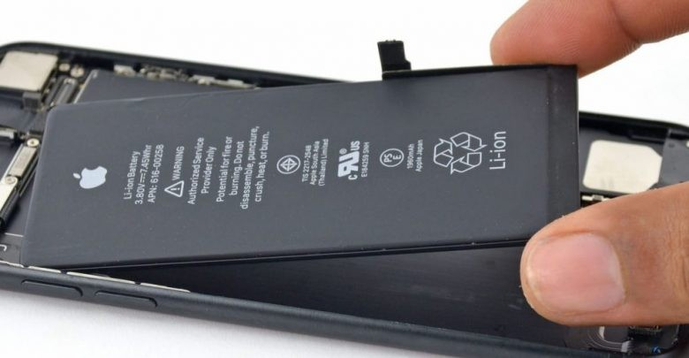 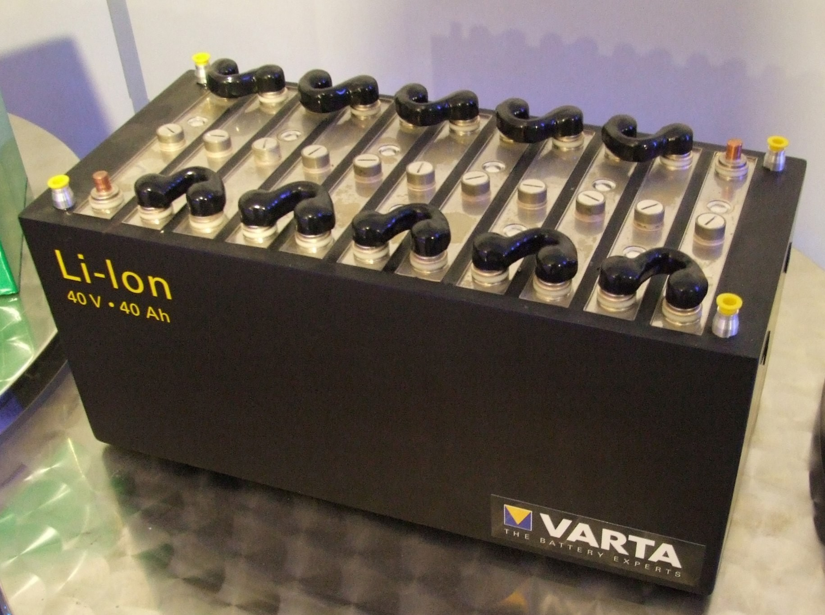

* + - 1. 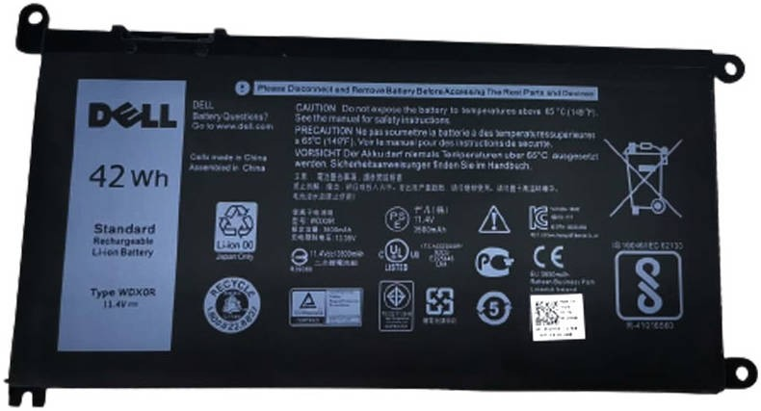lithium-ion battery in Phone (b) lithium-ion battery in Car

(c) lithium-ion battery in Laptop

Figure 1: Three examples on LIBs

### What is lithium-ion batteries?

Lithium (Li), a chemical element, is a soft silvery-white alkali metal that is highly reactive and flammable, the least dense of the solid chemical elements.

Lithium-ion is the most well-known chemical, which is used in rechargeable batteries. Lithium- ion batteries power devices that we use, such as electric vehicles, phones, laptops, and other devices. Lithium batteries consist of single or multiple lithium-ion cells with a protective circular plate and the positive (called Cathode) and negative (called Anode) electrodes at the end of the cell, as well as the electrolyte a liquid or gel that conducts electricity. It contains many chemicals, including lithium, cobalt, phosphate, iron, graphite, copper, nickel, manganese, cobalt oxide, salts and plastic [13]

### Why were lithium-ion batteries made?

Some of us are surprised that as long as these batteries cause a huge impact on the environment, why do we manufacture them? There is a risk when we use these batteries and when these batteries become inoperable and also when disposing of them. Therefore, there are many chemicals in LIBs that have an impact on the environment and that cause fires in landfills because of the flammability of these materials (copper and lithium) that react with water, producing flammable hydrogen gas. Their effects upon use vary according to the nature of use and conditions. surrounding it, for example, a decrease or increase in temperature causes a defect in the battery’s work, which leads to an explosion of the battery, and also the exposure of the battery to any accidents such as shocks, which leads to the leakage of toxic chemicals. and there are many risks. So, the main goal of the battery industry is to reduce environmental pollution. These batteries have revolutionized the world of the automotive industry, as they helped remove smoke emissions and reduce air pollution. There are many international initiatives such as the European Green Deal. Also, the United Kingdom pledges that in 2035 all means of transportation will use lithium-ion batteries, and this means that these batteries will increase in price unexpectedly. [11]

### How are spent lithium-ion batteries disposed of?

Disposal methods depend on national legislation and regulations, the ability to recycle, con- sumer behavior, and usually the user returns to the company responsible for the batteries to change or repair them. If a problem occurs, most countries sort batteries that are suitable for recycling, and others are buried, burned, or thrown in general waste, which leads to According to Veolia, one of the global waste treatment companies, there has been a 38% in accidents since 2017 due to the presence of lithium-ion batteries in the waste stream, and according to MFCs that specialize in collecting recyclables, crushing or penetrating LIBs during processing will cause fires or explosions. Explosions The German Recycling Federation also confirmed that 90% of fires in recent years were caused by LIBs. There are also many countries where fires occurred, such as the United Kingdom in 2017, as well as in the city of Tokyo in the garbage center that caught fire in 2017 and 2018. [11]

# Section Two: Title, objective, research questions

Title: Reducing e-waste (The environmental impacts of lithium-ion batteries and ways to reduce it)

Objective: To identify and measure the size of the problem and its environmental impacts, and to know the best ways to dispose of lithium-ion batteries in Jordan.

Qualitative and quantitative methods are two approaches used in data collection and analysis, and the choice of type depends on the research objectives and the nature of the questions.

1. Qualitative methods: Focuses on understanding the qualitative experiences and interpretations of individuals or groups. It is used to collect descriptive data such as interviews, observations, and open-ended surveys. It provides in-depth insights on exploring new topics, which allow for greater understanding and unexpected results.
2. Quantitative methods: Focuses on numerical data and statistics to identify patterns and generalize results to a large group of people and is considered suitable for analyzing large data that can predict and generalize results to extract meaningful insights.

The reason for choosing quantitative methods is because we want to analyze large data for measurement, make statistics, generalize the results, distribute them to the largest possible number, obtain them quickly, and analyze them using appropriate data analysis software.

The data was analyzed by the Microsoft Power BI software, which is a powerful business intelligence and data visualization tool that allows users to create interactive visualizations and reports in order to analyze and format data in an attractive, visual and easy-to-understand manner.

Questions: Quantitative Research.

Are you working in lithium batteries or a user?

* User (laptop, phone, electric/hybrid car, camera)
* Work (maintenance technician, car mechanic)

1. Used for lithium-ion batteries

Where are lithium-ion batteries used?

Laptop, phone, electric/hybrid car, camera, other

How often do you change your lithium-ion batteries?

Once a year, once in two years, once in three years, once in four years, once in more than five years, I haven't changed it yet

When you change the battery what do you do with the old battery?

I throw it away, take it to recycling companies to fix it, I sell it, other

1. I work for a company that specializes in lithium-ion batteries

Have you worked with lithium-ion batteries before?

Yes, no

Where do you work?

* A technician repairing phones, laptops and cameras in a store
* A technician repairing phones, laptops and cameras in a specialized company
* A mechanic for electric / hybrid cars in a store
* A mechanic for electric / hybrid cars in a specialized company
* Other

What problems or challenges have you encountered working with lithium-ion batteries?

* Leakage of chemicals while handling the battery
* Battery explosion
* There's no problem
* Other

What is the longest life of lithium-ion batteries?

One year, two years, three years, four years, five years

Does the company/shop train its employees to handle lithium-ion batteries properly?

Yes, no

Are public safety tools available in case of any risks?

Yes, no

Does the company / shop recycle lithium-ion batteries?

Yes, no

What are the processes used for recycling lithium-ion batteries? Note: The answer to the question in the event of the rotation process

Ultrasound infiltration, other

How many batteries are recycled per month? Note: The answer to the question in the event of the rotation process

Less than 20 batteries, more than 20 and less than 50 batteries, more than 50 and less than 100 batteries, more than 100 batteries

If the company/store does not carry out the recycling process, what are the methods used to dispose of the batteries?

* Dispose of it by throwing it in a landfill
* Disposal of them by burial under the soil
* Disposed of by incineration
* Give it to the specialized recycling companies
* Sell them in the market
* Other

How many batteries are disposed per month without recycling work?

Less than 20 batteries, more than 20 and less than 50 batteries, more than 50 and less than 100 batteries, more than 100 batteries

# Section Three: Reasons for choosing this research project

One of the main reasons is the increase in demand in the markets, as lithium-ion batteries are present everywhere in the world and operate on a range of devices, phones, computers, electric vehicles, etc., as they have become more widespread, which makes them an important field for research and development and in order to obtain a sustainable environment using this clean energy Which reduces climate pollution and batteries provide a place to store and use energy and help in devising solutions to problems and have an impact on various sectors and affect the international economy in addition to that the project will provide a reliable and innovative way to preserve the environment.

1. **Section Four: Literature sources searched**

Use of key literature sources to support your research question, objective or hypothesis

## Recycling of lithium-ion batteries: Recent advances and perspec- tives

In the current era, there is an increasing need for lithium-ion batteries, and at the present time companies are heading to manufacture more batteries, which leads to the disposal of batteries, which causes problems and harmful effects on the environment such as leaks and explosions due to poor disposal, so the recycling of spent lithium-ion batteries has begun to interest countries In recent years, due to the efforts of companies to improve batteries and make them more dense in energy, security and reasonable prices, the materials used in batteries are diverse, widely and ever-evolving, and thus there are difficulties in recycling batteries, so there are many modern and advanced technologies in the recycling process, including the recycling system Recycling lead-acid batteries, which works well in the United States, and the recycling rate reaches 99%, but lithium batteries are different from previous batteries in terms of the chemical composition of the components, and studies have shown that the mass of lithium-ion batteries is 60% of lead, so that it becomes easy to disassemble the components from The battery, but the other components in the battery are complex and not easy to recycle, because there is a variety of components In materials, shapes and sizes, therefore, there are two processes for recycling the physical and chemical process due to the complex assembly of LIBs in addition to the diversity, and the physical processes include dismantling, crushing, sorting, washing, magnetic separation and heat treatment to prevent leaks and explosions during the recycling process. In this way, the components and spent materials will be separated, and studies have shown that these steps of the recycling process are effective in enhancing the filtration efficiency of the treatment process and are applicable. The pyrometallurgical process has been used by commercial recycling plants to recover cobalt eg umicore. In this process large battery packs are simply dismantled into individual cells. The impact of recycling on the environment, such as the consumption of resources and energy, and waste emissions that cannot be treated, including solid, liquid and gas, which are buried or burned, but are less harmful to the environment. However, many recycling operations aim to recover valuable metals [14]

## The Environmental Impacts of Recycling Portable Lithium-Ion Batteries

Waste of electronic and electrical equipment is one of the fastest growing wastes, and recycling processes work to reduce the growing waste that needs more space for disposal. Lithium- ion batteries are the most widely used type in portable electronic devices. These batteries contain lower levels of toxic substances. Recycling leads to a reduction in Energy consumption, reducing gases and global warming, which makes there an abundance of natural resources by 51.3% when compared to landfills. There are two recycling processes, extracting minerals from water or the thermal mining process. For example, in Australia, spent lithium-ion batteries end up in landfills by 98.3%. The Australian Battery Recycling Initiative works to collect expired batteries for recycling. Portable battery recycling technologies are divided into three categories: mechanical processes, pyrometallurgical processes, and metallurgical metallurgical processes. As for the mechanical processes, they have two purposes: disassembling the battery and

liberating the components, and include crushing and shredding materials according to physical properties. As for operations Refractory mineral extraction is done by high temperatures to recover the materials and includes smelting, distillation and refining. Data was collected from 11 companies that recycle lithium-ion batteries. In addition to further research, life cycle assessment (LCA) was used. Through the results, metallurgical processes with water and heat indicate the recovery of materials such as copper and cobalt from lithium-ion batteries. Steel, nickel and aluminum were found Although steel is the least component of the battery, it is recovered and processed, but these companies confirmed the high cost of recycling and confirm that mineral water treatment processes are the most material recovery processes. As for the impact of recycling on the environment, there are processes that need to bury the materials for treatment or need to burn, and some materials are thrown in the landfill because they are not suitable for treatment. Among the most common materials that are buried are plastic, copper and nickel, which cause deposition in the soil and emissions of methane and oxide gas Nitrous and carbon dioxide from plastic. [15]

## Battery Recycling Technologies: Recycling Waste Lithium-Ion Batteries with the Impact on the Environment In-View

Technologies are expanding in the recycling of lithium-ion batteries in accordance with environmental laws. Among these technologies is the use of dissolving technology that includes suitable non-toxic organic solvents to effectively dissolve the bonded materials to avoid a lot of pollution, as well as the hydrolysis technology of LiPF6 by converting it into useful materials instead of using virgin materials. Since Sony made the first commercial lithium cell in 1991, there has been great interest in the fact that it is superior to other batteries in terms of energy density and is important for portable electronics and electric vehicles. Lithium-ion batteries are detailed systems as electrochemical energy sources such as phones, computers, cameras and other modern devices, except that studies have shown that the quantities of chemical components that are deposited after the end of the life span of LiBs, so they must be handled with caution and the solution is recycling to protect the environment and waste sustainability and achieve economic gains and Reducing the use of natural resources and most of the materials that are recovered (cobalt, lithium and nickel) are not precious metals, but rather alternative precursors for the installation of new batteries. After evaluating the recycling processes, the processes mentioned above are among the best technologies used in the treatment process and have proven to be very successful and achieve sustainable waste. [16]

## Safer Electrolytes for Lithium-Ion Batteries: State of the Art and Perspectives

Lithium-ion batteries are currently being widely re-applied due to the severe safety concerns that lithium cells are exposed to due to mechanical, thermal or electrical misuse. Examinations and analysis of the latest systems and potential alternatives are being conducted in order to achieve the best means of protection, because lithium-ion batteries have become important in the transportation sector. Modern, so it enables the achievement of sustainable transport, and the main concerns for it are the exposure of cells to conditions that lead to the occurrence of risks, so there is a need for improvement in battery technology, because the world is heading for widespread application. There are three conditions for misuse that lead to the generation of large heat inside the lithium-ion cell. Abuse Chemical, electrical and thermal use, but there are safety mechanisms such as safety switches and voltage and current monitoring systems to prevent the generation of high heat, which leads to shut down and thus the flow of current. In the worst case, this may lead to a fire or explosion in the cell. So why is it being used increasingly, because its performance is superior to To a large extent due to an increase in the cell voltage to two to three times and sometimes up to four times for each cell. For safety, flammable electronics have been replaced with water-safe electronics. The electronics system has contributed to the commercial success of lithium batteries over the past 25 years and is highly suitable for small portable electronics. [17]

## Prospects for lithium-ion batteries and beyond a 2030 vision

The world is witnessing a commercial development in (LIBs) for the first time for portable electronics, it has become ubiquitous in daily life in electric cars, medical devices, smartwatches and drones, because there is a doubling in the use of batteries and the reason for reducing and eliminating carbon emissions, so it is difficult to LIBs are nearing the end of their lives. Engineering and chemical approaches are still available to improve performance. So a holistic approach will be needed to unlock higher energy densities while maintaining lifespan and integrity. A strong focus is on mitigating degradation because as voltage increases, degradation becomes more severe. So, the primary solution is to look for durable materials. Volts and move away from traditional liquid electronics and reduce combustion processes to prevent risks. The search for new materials is a great challenge, as also the procession of development, such as running batteries on Internet of Things devices, which require algorithms and high costs. As for safety, it will be higher because it will calculate the voltage and heat to determine the capacity for safety and the use of sustainable energy. Also, research and applications are still needed more than ever in order to understand the challenges that will be encountered along the way. [18]

# Section Five: Activities and timescales

## First Semester

|  |  |  |  |
| --- | --- | --- | --- |
| Task | Start Date | Finish Date | Duration |
| * General research topic * Research about the theme and its subtopics and choosing one subtopic * Write an introduction about the theme topic | 10/11/2022 | 16/11/2022 | Week |
| * Modify introduction about digital transformation * Change the subtopic to Lithium-ion batteries * More research about the chosen topic and subtopic * Find at least 10 papers most relevance for topic * Adding the introduction to the proposal using Overleaf | 17/11/2022 | 23/11/2022 | Week |
| * Modify introduction about digital transformation * Modify introduction subtopic to Lithium-ion batteries * Submit 5 most relevant papers to their research topic * Summarize the most relevant papers * Start formulating the research objectives and research questions | 24/11/2022 | 30/11/2022 | Week |
| * Summarize three to four papers from the chosen papers, as part of the literature review * Finalize the research idea and state clearly the research questions * add details about digital transformation * add details for subtopic to Lithium-ion batteries | 1/12/2022 | 7/12/2022 | Week |
| * Modify Summary of the chosen papers * Suggest a possible source of data (How will collect the data?) | 8/12/2022 | 14/12/2022 | Week |
| * Review the research source of data * Review the research questions | 15/12/2022 | 21/12/2022 | Week |
| * Complete and finalize the following parts on overleaf:  1. Research objectives and the main research questions 2. The literature reviews 3. Sources of data (How will collect data?) | 22/12/2022 | 28/12/2022 | Week |
| * Suggest the research approach and methodologies | 29/12/202 | 4/1/2023 | Week |
| * Finalize the suggested research approach and methodologies * Working more on the final version proposal and the presentation | 5/1/2023 | 11/1/2023 | Week |
| * End of work on your proposal * End of work on your presentation | 12/1/2023 | 18/1/2023 | Week |
| * Submission of proposal and presentation to doctor | 19/1/2023 | 25/1/2023 | Week |
|  |  |  |  |

## Second Semester

|  |  |  |  |
| --- | --- | --- | --- |
| Task | Start Date | Finish Date | Duration |
| * Collecting data | 1/3/2023 | 30/3/2023 | 4 Week |
| * Analyze the data collected from the survey | 1/4/2023 | 8/4/2023 | Week |
| * Making solutions to the main problems identified as a result of the data collected | 9/4/2023 | 22/4/2023 | 2 Week |
| * Conclusion | 25/4/2023 | 9/5/2023 | 2 Week |
| * Final submission of presentation and word document to doctor | 10/5/2023 | 25/5/2023 | 2 Week |

# Section Six: Research approach and methodologies

The research methodology that I used is quantitative by collecting questions about the topic that I am researching, which is the impact of lithium-ion batteries on the environment in Jordan. After collecting the questions that fit the topic, I made a survey containing questions for battery workers and users, and I published them on the specialized companies. I also made some calls. These companies know other things that are useful for research, and after collecting the data, I will analyze it and find the best appropriate ways to reduce the environmental impact of these batteries in Jordan. Other countries can benefit from this research because the world is heading towards this category of lithium-ion batteries, which is a good alternative and more suitable for the environment and has a future.

**7 Analysis of data: -**

The research data was collected through the work of a survey in order to know the environmental effects of lithium batteries in Jordan and what are the risks and to find a solution to these problems. It was distributed to users and people who work with these batteries, such as companies, shops, etc.

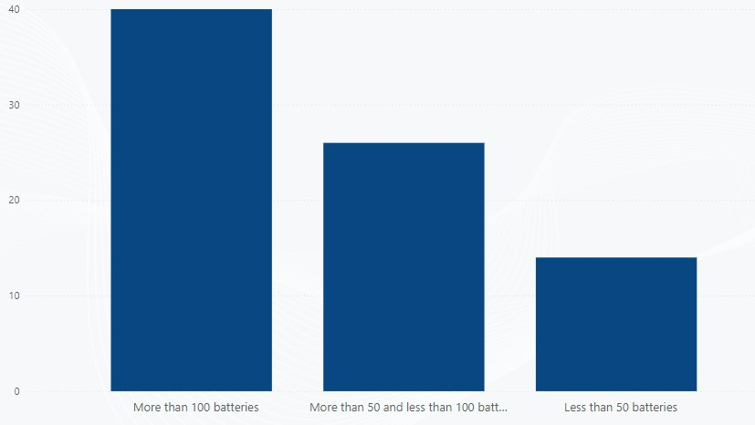

Figure 3: How many batteries are disposed of per month without recycling work?

Figure 3 indicates that there are thousands of batteries that are disposed of every month, and Jordanian companies have not been able to recycle these batteries.

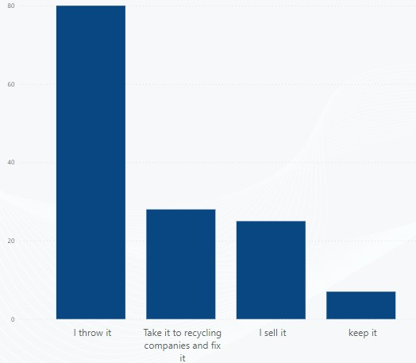

Figure 4: When you change the battery what do you do with the old battery?

Figure 4 indicates that 57% of people, when they change batteries, whether for phones, cameras, laptops, or cars, throw away the batteries that have been changed, and this indicates that there are great environmental risks that will occur due to throwing batteries, and 38% of people sell them to stores or giving it to companies to carry out recycling operations for these used batteries. And 5% of people keep them, and this indicates the high risk of these batteries when they are left and not used.

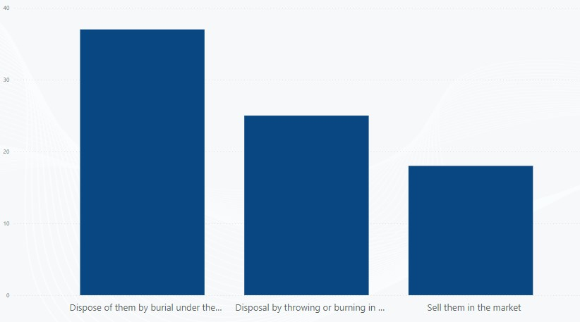

Figure 5: If the company/ shop does not recycle, what methods are used to dispose of the batteries?

Figure 5 refers to the methods used to dispose of used or expired batteries. It indicates that

46% of companies and shops dispose of these batteries by burying them under the ground, and 31% of companies and shops dispose of these batteries by throwing or burning them in the ground. Waste dump, and 23% of companies and stores dispose of these batteries by selling them in the market. As a result, there is a great danger to the environment, and this indicates that there is no solution to these problems that occur to the environment.

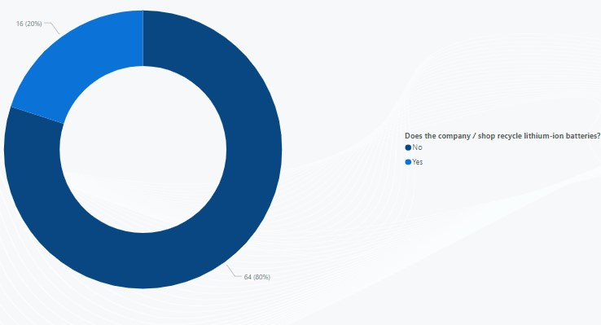

Figure 6: Does the company/shop recycle lithium-ion batteries?

Figure 6 indicates that there are 80% of companies and stores do not carry out the recycling process and that 20% of companies and stores do the recycling process, and this indicates that in Jordan there are not many specialized companies in the field of recycling given the large number of batteries that are destroyed and dispose of it.

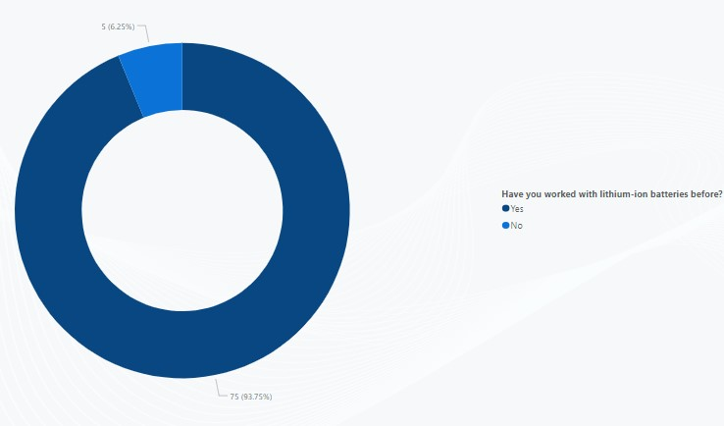

Figure 7: Have you worked with lithium-ion batteries before?

Figure 7 indicates that 93.75% of workers in companies can deal with lithium batteries, and 6.25% of workers cannot deal with these batteries, and this indicates that recycling operations can be carried out, given that all workers understand the nature of battery work. And they know how to deal with these batteries and their risks.

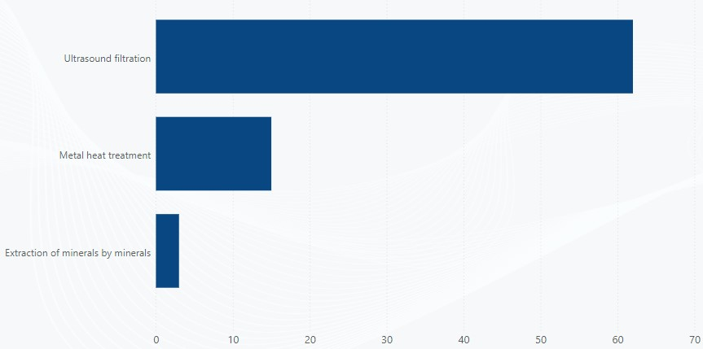

Figure 8: What processes are used to recycle lithium-ion batteries?

Figure 8 indicates that 77.5% say that the best way to do recycling is ultrasonic filtration, 18.75% prefer recycling by heat treatment with metals, and 3.75% prefer recycling by extracting minerals This indicates the awareness of the employees and makes us conclude that ultrasonic filtration is the best method for recycling operations.

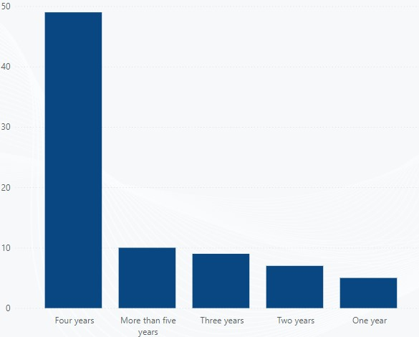

Figure 9: What is the longest life of lithium-ion batteries?

Figure 9 indicates that there are certain ages for the batteries according to use, and indicates that 74% of the batteries have a life of more than four years and that 26% of the batteries have a life span between one to three years old, and this shows that we need companies specialized in recycling in view of the ages of the batteries.

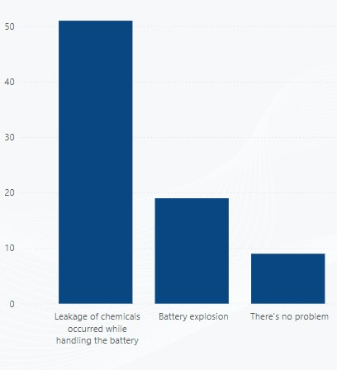

Figure 10: What problems or challenges have you encountered working with lithium-ion batteries?

Figure 10 illustrates the problems, risks, and challenges that workers face while dealing with these batteries. It was found that 65% of the batteries leaked chemicals, and 24% of the batteries explode while working with them incorrectly, or that the person was using them in an inappropriate way. And that 11% of batteries do not cause any problems, and therefore lithium-ion batteries are very dangerous and must be handled with care and require experience and high skill among workers, and for this reason, there are not many companies that carry out the recycling process.

**9 Conclusion: -**

Based on the research idea that aims to identify and measure the size of the problem and its environmental effects, and to know the best ways to get rid of lithium-ion batteries in Jordan, and based on the results and conclusions obtained, it was found that lithium-ion batteries contribute 58% to preserving the environment and 30% impact Less air pollution and 28% less impact on global warming. Based on the results of the analysis, it was found that there are many problems that the environment suffers from as a result of the wrong disposal of lithium-ion batteries, such as throwing and burying them under the soil and throwing them in a landfill. All these behaviors cause problems for the environment and lead to the deterioration of healthy life. For people, therefore, there are many ways to conduct recycling operations to avoid the destruction of the environment by reducing the damage resulting from the disposal of these batteries. There are three best ways to recycle these unusable batteries, including ultrasonic filtration, mineral heat treatment, and metallurgical extraction. These methods will help demand A lot on new batteries and it will restructure the unfit batteries to make them work like new batteries again. Also, based on the results that were analyzed, it is possible to benefit from many materials such as (cobalt, lithium and nickel) that you extract from recycling operations. Most countries have looked at This matter, Germany and Spain began to invest in order to find solutions to these problems, as well as international companies such as Mitsubishi Materials in Japan, carry out a recycling process for metals such as cobalt and lithium extracted from lithium-ion batteries, and also the Mercedes company began building a recycling plant in southern Germany, and it will contribute more than 50,000 A unit of batteries is processed, and based on the conclusions, it was found that Jordan does not contain any specialized company that carries out a comprehensive recycling process for all components of lithium-ion batteries. Therefore, it was suggested that a company specialized in the recycling process of lithium batteries be established due to the increasing demand for these batteries, and it will reduce the problems and the damage it causes to the environment, and this helps to achieve a sustainable environment.[15][16]

**References**

1. G. Vial, “Understanding digital transformation: A review and a research agenda,” *Managing Digital Transformation*, pp. 13–66, 2021.
2. P. C. Verhoef, T. Broekhuizen, Y. Bart, A. Bhattacharya, J. Q. Dong, N. Fabian, and M. Haenlein, “Digital transformation: A multidisciplinary reflection and research agenda,” *Journal of Business Research*, vol. 122, pp. 889–901, 2021.
3. I. Mergel, N. Edelmann, and N. Haug, “Defining digital transformation: Results from expert interviews,” *Government information quarterly*, vol. 36, no. 4, p. 101385, 2019.
4. E. A. Khitskov, S. V. Veretekhina, A. V. Medvedeva, O. L. Mnatsakanyan, E. G. Shmakova, and A. Kotenev, “Digital transformation of society: problems entering in the digital economy,” *Eurasian Journal of Analytical Chemistry*, vol. 12, no. 5, pp. 855–873, 2017.
5. T. Corejova and R. Chinoracky, “Assessing the potential for digital transformation,” *Sustainability*, vol. 13, no. 19, p. 11040, 2021.
6. R. W. Scholz, E. J. Bartelsman, S. Diefenbach, L. Franke, A. Grunwald, D. Helbing, R. Hill, L. Hilty, M. Höjer, S. Klauser *et al.*, “Unintended side effects of the digital transition:

European scientists’ messages from a proposition-based expert round table,” *Sustainability*, vol. 10, no. 6, p. 2001, 2018.

1. D. Ulas, “Digital transformation process and smes,” *Procedia Computer Science*, vol. 158, pp. 662–671, 2019.
2. A. Bilyalova, D. Salimova, and T. Zelenina, “Digital transformation in education,” in *International conference on integrated science*. Springer, 2019, pp. 265–276.
3. B. Bilgili and E. Koc, “Digital transformation in tourism,” in *Emerging Transformations in Tourism and Hospitality*. Routledge, 2021, pp. 53–65.
4. D. Qosimova and A. Ko‘chimov, “Fundamentals of investment environment in the process of digital transformation of the economy,” *Vital Annex: International Journal of Novel Research in Advanced Sciences*, vol. 1, no. 5, pp. 55–59, 2022.
5. W. Mrozik, M. A. Rajaeifar, O. Heidrich, and P. Christensen, “Environmental impacts, pollution sources and pathways of spent lithium-ion batteries,” *Energy & Environmental Science*, vol. 14, no. 12, pp. 6099–6121, 2021.
6. E. Ayerbe, M. Berecibar, S. Clark, A. A. Franco, and J. Ruhland, “Digitalization of battery manufacturing: current status, challenges, and opportunities,” *Advanced Energy Materials*, vol. 12, no. 17, p. 2102696, 2022.
7. E. Safety, “What are lithium-ion batteries?” *Energy & Environmental Science*, vol. 11, no. 15, pp. 111–123, 2021.
8. B. Huang, Z. Pan, X. Su, and L. An, “Recycling of lithium-ion batteries: Recent advances and perspectives,” *Journal of Power Sources*, vol. 399, pp. 274–286, 2018.
9. A. Boyden, V. K. Soo, and M. Doolan, “The environmental impacts of recycling portable lithium-ion batteries,” *Procedia Cirp*, vol. 48, pp. 188–193, 2016.
10. O. E. Bankole, C. Gong, and L. Lei, “Battery recycling technologies: Recycling waste lithium ion batteries with the impact on the environment in-view,” *Journal of Environment and Ecology*, vol. 4, no. 1, pp. 14–28, 2013.
11. J. Kalhoff, G. G. Eshetu, D. Bresser, and S. Passerini, “Safer electrolytes for lithium-ion batteries: state of the art and perspectives,” *ChemSusChem*, vol. 8, no. 13, pp. 2154–2175, 2015.
12. C. P. Grey and D. S. Hall, “Prospects for lithium-ion batteries and beyond—a 2030 vision,” *Nature Communications*, vol. 11, no. 1, pp. 1–4, 2020.